Audience->Geo->Location:

We get to see the heatmap of the users as per country/city/continents.

Audience->Mobile->Devices:

We can further drill down to our mobile audiences to see the exact configuration of each devices that are visiting our website.

Bounce Rate:

This is the number of visitors who come to your website and leave without visiting any page beyond the one they landed on. Generally you want the visitors to stay on your website.

Avg Session Duration:

This tells you the average amount of time visitors spent on the website before leaving.

Pages/Session:

This is the number of individual pages a person visits while on the website before leaving.

Behavior Flow

Behavior-> Behavior Flow:

Knowing the visitor numbers are good however we need to know when they move from one page to another, where are they going?

Landing Page: The page user sees after a search or typing the website url.

Exit Pages: The page where the user drops off or close the url/browser tab.

Events:

Behavior->Events -> Top Events

You clicked on the website to move across pages/ play a video/ download link/ your discount code button.

Site Speed:

Behavior -> Site Speed

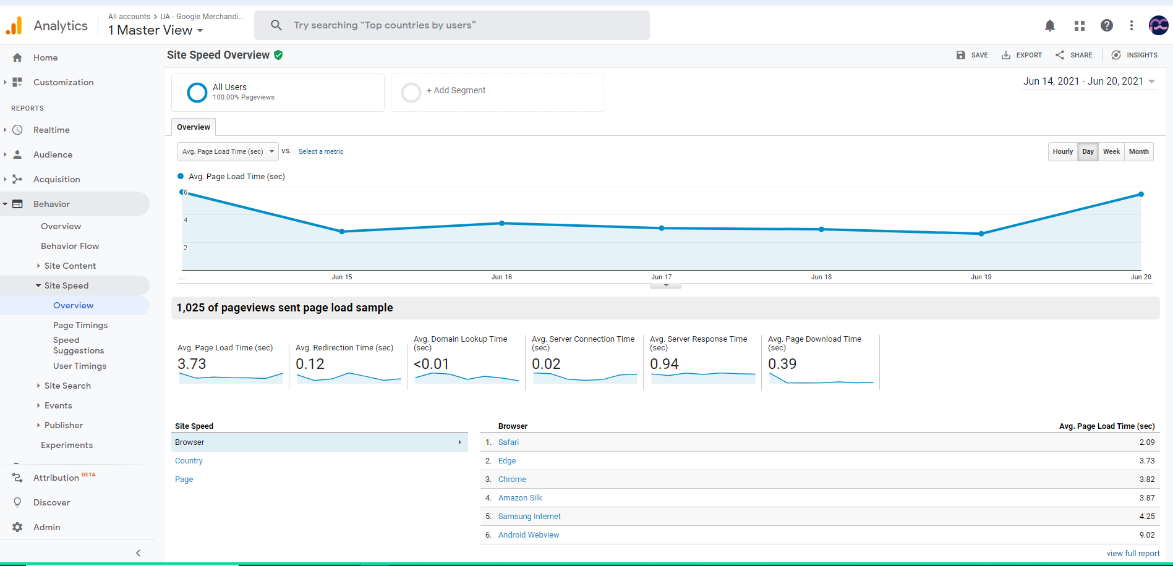

Average page load time: The average amount of time it takes for pages to load.

Average redirection time: the average amount of time spent in redirects before fetching a page.

Average domain lookup time: The average amount of time spent in DNS lookup for a page.

Average server connection time: The average amount of time spent establishing a TCP connection for a page.

Example: Amazon.ca -> DNS->192.168.0.1 -> Connection to server -> website home page -> server response -> website being shown in user browser

Average server response time: The average amount of time your server takes to respond to a user request

Average page download time: The average amount of time it takes to download a page.

Conversion:

Conversion-> Goals->Overview:

The primary goal of this section is to track what user action or main goal was.

Whether it’s making a purchase, contacting you, or signing up for your email list.

What is a conversion?

There are multiple type of conversions it can be every time a visitor makes a purchase, signing up for email list, fill out a form on website or when they visit specific pages in set sequence.

Setting up goals:

Admin -> Goals

Conversion Rate: It’s the number of conversions dividing by total visitors on the website.

Example: if order complete was the goal and 50/ 1000 users ended buying then 5% is the conversion rate.

Different goals help you see which pages and online marketing activities are helping you achieve the main goals you’ve set. This directly or indirectly helps you tweak your strategy for improved results over time.

Smart Goal:

It’s a different category altogether.

Smart goals helps you identify the most engaged users on your website and counts their visits as conversions.

How do smart goals works?

Behind the scene these are algorithms. These algorithms scan dozens of signals within your website sessions to determine which signals are most likely to result in conversion.

How to set up a goal and it’s respective URL:

Admin-> Goals

Reverse Goal Path:

This is to find hurdles in conversion and keeping the steps as possible.

Goals-> Funnel Visualization:

This only works for destination goal to track multiple steps in conversion process.

It will help to analyze where people are dropping off in the process.

This will help to ease out the hurdles and simplify the process and help identify any glitches along the way.

Multi-channel Funnels:

1. Organic Search - 92%
2. Direct - 18 %
3. Referral – 2%
4. Paid Search - ~1%
5. Social Network -~1%
6. Email - ~1%

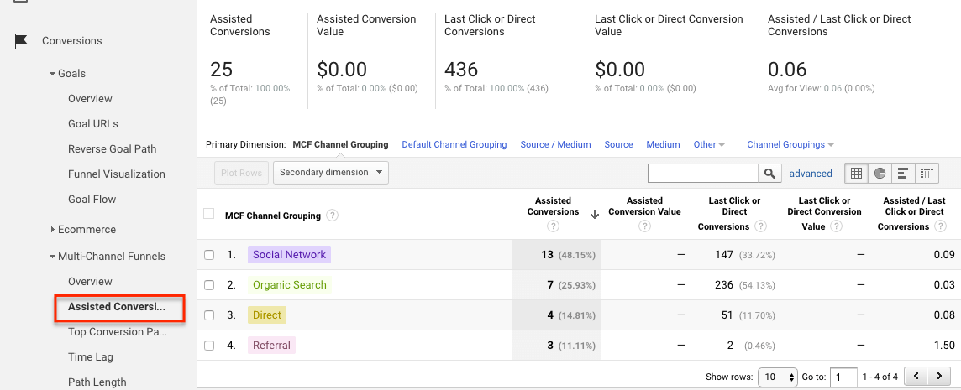

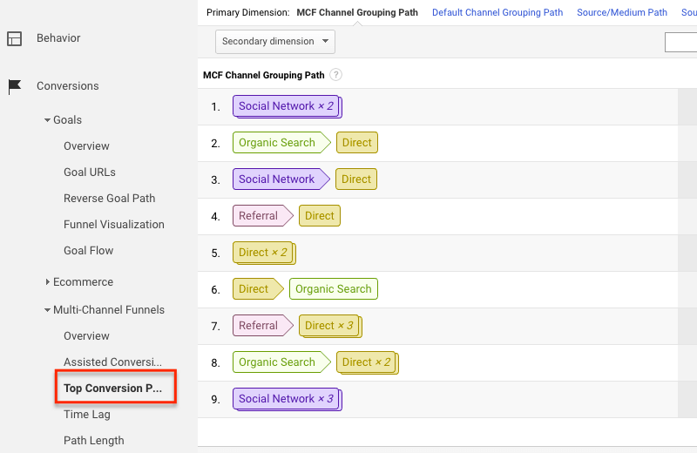

Audience:

The audience highlights about the who makes up your website traffic.

Real time

Real time allows you to monitor activity as it happens on your website and reports are updated continuously.

Uses of the real time data

1. To monitor the one-day promotion activities.
2. To monitor whether the new change/feature is working as expected.
3. Monitor the immediate effects on traffic from a blog/social network post or tweet.
4. This is to test that the goals are firing real time and conversions are not lost.
5. Filters: Creating a new view with custom filters can be tested real time.